**MID-TERM Three EXAMINATION –2022**

**CLASS: PRIMARY one**

**SUBJECT: MATHEMATICS**

**Name: …………………………………………….……Stream: …………**

1. **Add:**
2. 3 + 5 = (b) T O

4 3

+ 2 2

1. **Name the set.**



A set of 3 __________________

1. **Fill in the missing number.**

30, 29,______,27, 26_____,

1. **Tell the time.**

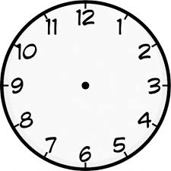It is ________________o’clock.

1. **Multiply:**
2. 5 x 2 = (b) 3

x 3

1. **Write the number in words.**
2. 16, ___________________ (b) 20, ___________________
3. **Complete the tens and ones.**

54 = ______tens _______ones

_____tens ______ones = 88

1. **Name the shapes.**

**a**

**a _________________________**

**b _________________________**

**c**

**b**

**c _________________________**

**(circle, triangle, zigzag, rectangle)**

1. **Work out:**
2. $\frac{4}{8}$ + $\frac{3}{8}$**=** (b) $\frac{7}{9 }$ **– $\frac{5}{9}$ =**
3. One girl has 2 legs. How many legs do 4 girls have?
4. **Use heavier or lighter**

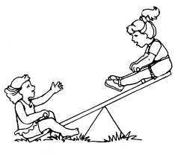

**Okoti**

**Omaru**

1. Okoti is _________________than Omaru.
2. Omaru is _______________than Okoti.
3. Shade the fractions.
4. = $\frac{1}{2 }$
5. = $\frac{2}{6 }$
6. **Opio has ten cows. Tim has six cows.**
7. Who has many cows?

___________________________________________________

1. Who has the smaller number of cows?

___________________________________________________

1. How many cows do they have altogether?

___________________________________________________

1. **Complete correctly.**

**T O T O**

**3 4**

1. Use the number line to work out.

5 + 3 = _____________

0 1 2 3 4 5 6 7 8 9 10 11 12

1. **Use taller or shorter.**

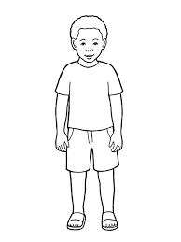 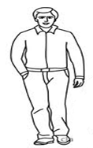

**Tom Gad**

1. Tom is ________________than Gad.
2. Gad is _________________than Tom.
3. We keep our money safely in the _____________________

**(bank, pot)**

1. **Workout correctly.**
2. Sh. 5 (b) sh. 4 0

+ sh. 3 + sh. 2 0

1. Sam had nine eggs, three eggs broke. How many eggs did he remain with?
2. **Match correctly.**

3 x 0 4

2 + 3 0

8 – 4 5

1. **Use** **the sets to answer the questions.**

**A B**

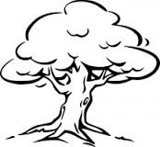  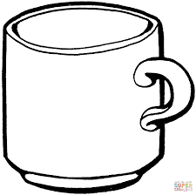

  

1. Which set has more members?

________________________________________________

1. Which set has less members?

__________________________________________________

1. How many members do they have altogether?

_________________________________________________

1. **Subtract / take away / minus**
2. 9 – 3 = (b) **T O**

7 4

– 2 1

1. **Circle the bigger number.**
2. 15 and 98
3. 40 and 14
4. **Study the graph and answer the questions.**

|  |  |  |  |  |
| --- | --- | --- | --- | --- |
|  |  |  |  |  |
|  |  |  |  |  |
|  |  |  |  |  |
|  |  |  |  |  |
|  |  |  |  |  |
| **Ann** | **Sarah** | **Teddy** | **Fred** | **Stella** |

1. Who has the smallest number of balls?

_____________________________________________________

1. How many balls has Teddy?

_____________________________________________________

1. ___________________and ________________have the same number of balls.
2. Who has the biggest number of balls?

_____________________________________________________

1. They have ___________________balls altogether.

***THE END***